QCA Analysis and Empirical Results
1. Measurement and Calibration
In processing the original texts, this study employed a self-developed research tool that integrates an API interface to call the DeepSeek-V4-Flash model. Based on prompts constructed around the conditional variables—for example, for the condition “individual interest framing,” the prompts include: theoretical source (derived from Yuan and Shen, 2021), defining that in complaint texts the complainant anchors the harmed or benefited subject to the individual self, as opposed to collective interest framing; high operational level, where the harmed/benefited subject is exclusively the individual; medium operational level, where both individual and collective references are present; and low operational level, where the harmed/benefited subject is only collective or not clearly specified—the large language model generated scores, which were subsequently manually verified to produce the final textual scoring results. Visualization-based inspection indicates that the score distribution is reasonable (see Figure 1).
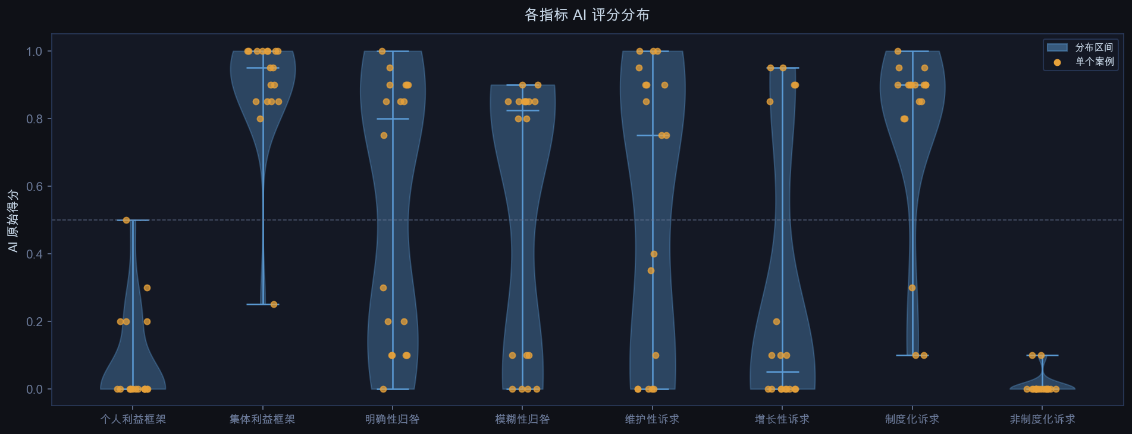
Figure 1: Distribution of Scores
The conditional variables used in this study are presented in Figure 1 (for detailed descriptions, see Research Design and Prototype.docx).
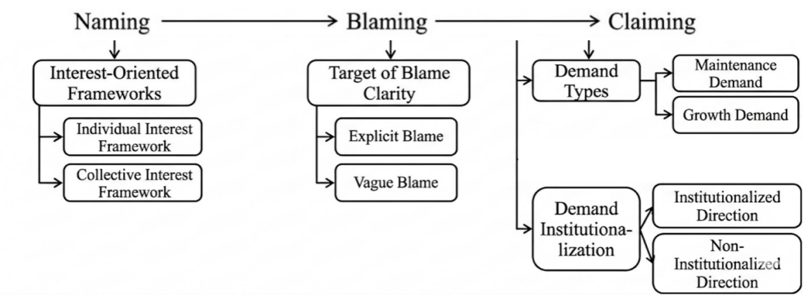
Figure 2: The Model of Prototype

Building on existing studies, this article adopts the direct calibration method (Ragin & Fiss, 2008) to transform raw data into fuzzy-set membership scores, according to the data types of the conditions and the outcome. Drawing on the calibration standards proposed by Du & Jia (2017) in the Chinese context, and considering the empirical characteristics of the cases, the crossover point for all condition variables is set at 0.5, the threshold for full non-membership is set at 0.05, and the threshold for full membership is set at 0.95. For the variable of attention allocation, the crossover point is set at 0.5, with full membership calibrated at 0.05 and full non-membership at 0.95. The calibration information for all conditions and the outcome is presented in Table 1. The calibration standards for each condition are constructed based on semantic classification rules derived from the “naming–blaming–claiming” theoretical framework, thereby enabling the transformation from textual information to set membership scores. The calibrated scores for each textual case are illustrated in Figure 2.
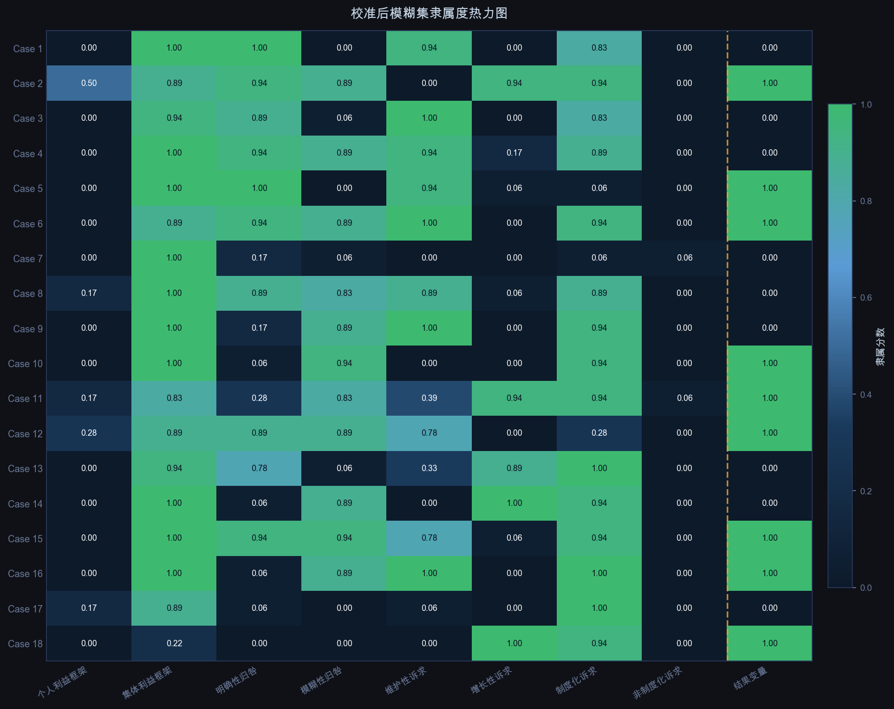
Figure 2. Heatmap of Fuzzy-set Membership Scores after Calibration
2. Necessity Analysis of Single Conditions
In QCA, a condition is considered necessary if it is always present when the outcome occurs (Ragin and Fiss, 2008). Consistency serves as the key criterion for evaluating necessity, and a condition is regarded as necessary when its consistency exceeds 0.90 (Ragin and Fiss, 2008). Table 1 reports the results calculated using the QCA package in R (Dusa, 2019) implemented through the self-developed tool of this study. The results show that the consistency levels of all conditions are below 0.90. Therefore, no condition can be identified as a strictly necessary condition for high or non-high levels of government responsiveness.
Nevertheless, several conditions exhibit relatively strong explanatory power. In particular, the consistency of “~individual interest framing” and “~non-institutional claims” reaches 0.9259 and 0.9444, respectively, both exceeding the 0.90 threshold, indicating that they can be considered necessary conditions. In addition, the consistency of “collective interest framing” is 0.8518. Although it does not meet the strict requirement for necessity, it is close to the threshold and can therefore be regarded as a quasi-necessary condition. These findings suggest that, in almost all cases where government responsiveness occurs, strong individual-oriented framing is largely absent, and non-institutionalized or informal claims are rarely observed. This implies that, when selecting which complaints to respond to, governments tend to prioritize whether the expression is framed in public terms and whether it falls within an institutionalized framework.
In contrast, the remaining conditions—such as explicit blame attribution, vague blame attribution, maintenance-oriented claims, growth-oriented claims, and institutional claims—show consistency levels well below 0.80, indicating that these factors do not independently determine the occurrence of the outcome and are more likely to exert influence through configurational combinations.
Table 1. Necessity Analysis of Single Conditions
Condition | Consistency | Coverage | Necessity
Individual Interest Framing | 0.0741 | 0.6663 | Non
~Individual Interest Framing | 0.9259 | 0.4902 | Necessary
Collective Interest Framing | 0.8518 | 0.4742 | Quasi-Necessary
~Collective Interest Framing | 0.1482 | 0.727 | Non
Explicit Blame Attribution | 0.5062 | 0.4795 | Non
~Explicit Blame Attribution | 0.4938 | 0.5229 | Non
Diffuse Blame Attribution | 0.7716 | 0.5507 | Non
~Diffuse Blame Attribution | 0.2284 | 0.3815 | Non
Maintenance-oriented Claims | 0.4753 | 0.5066 | Non
~Maintenance-oriented Claims | 0.5247 | 0.4942 | Non
Growth-oriented Claims | 0.3581 | 0.6131 | Non
~Growth-oriented Claims | 0.6419 | 0.4534 | Non
Institutional Claims | 0.5679 | 0.4532 | Non
~Institutional Claims | 0.4321 | 0.5785 | Non
Non-institutional Claims | 0.0556 | 0.6917 | Non
~Non-institutional Claims | 0.9444 | 0.492 | Necessary

- Configurational Analysis of Sufficiency Conditions
Schneider and Wagemann (2012) suggest that the consistency threshold for sufficiency should not be lower than 0.75. Depending on the specific research context, the frequency threshold should be determined according to sample size (Schneider & Wagemann, 2012). For small- to medium-sized samples, a frequency threshold of 1 is generally appropriate (Zhang et al., 2019), whereas for large samples the threshold should be greater than 1. In empirical applications, it is also necessary to consider the distribution of cases in the truth table as well as the researcher's familiarity with the cases. Accordingly, this study sets the consistency threshold at 0.80, the frequency threshold at 1, and the PRI consistency threshold at 0.75, resulting in a final solution covering 17 cases.
Based on these parameter settings, three sufficient configurational paths leading to government responsiveness are identified from the truth table. The overall solution consistency is 0.8043, and the solution coverage is 0.4568, indicating that these configurations explain approximately 45.68% of the cases at a relatively high level of consistency, reflecting the typical QCA characteristics of multiple conjunctural causation and equifinality. As shown in the consistency-coverage scatter plot, Path 2 exhibits the highest consistency (0.8435), indicating the strongest stability; Path 1 shows a consistency of 0.7417, which is close to the acceptable threshold; and Path 3 has a slightly lower consistency (0.7498), but still falls within an acceptable range. Notably, Path 3 has the highest coverage (0.2038), suggesting that it accounts for a broader set of empirical cases, thereby highlighting the trade-off between consistency and explanatory scope across different configurations.
Path 1 can be conceptualized as a non-blaming growth-oriented path. Its core configuration is characterized by the absence of both explicit blame attribution (⊗) and diffuse blame attribution (⊗), while growth-oriented claims appear as a peripheral condition (●). This indicates a “weak-blame” or “non-blame” structure at the blaming stage, in which the complaint does not construct a clear attribution of responsibility. Instead, it directly advances growth-oriented claims at the claiming stage, such as requests for expanded services or infrastructural improvements. In this configuration, the issue is reframed as a development-oriented agenda, thereby bypassing disputes over responsibility attribution. This finding suggests that government responsiveness can be triggered even in the absence of clear blame, as long as the claim possesses policy extensibility and aligns with development-oriented governance goals. In essence, this path reflects a logic in which development-oriented claims substitute for blame attribution as the key driver of response.
Path 2 can be labeled as an institutionally embedded diffuse-blame path. Its defining feature is the presence of diffuse blame attribution as a core condition (●), accompanied by the absence of both maintenance-oriented and growth-oriented claims (⊗), while institutional claims appear as a peripheral condition (●). The key mechanism of this configuration lies in the strategic use of diffuse blame to direct responsibility toward broad entities such as “relevant authorities,” thereby avoiding direct accountability conflicts. Simultaneously, the complaint is embedded within institutional frameworks through references to policies, regulations, or formal procedures. This combination of diffuse blame and institutional embedding reduces both responsibility risks and execution costs for government actors, which explains its highest consistency among all paths. This result highlights that, within the Chinese governance context, institutional alignment is more critical than the precision of blame attribution in eliciting government responses.
Path 3 can be described as a direct governance maintenance path. It is characterized by the presence of maintenance-oriented claims as a core condition (●) and the absence of institutional claims as a core absence condition (⊗), with other conditions remaining unspecified. Unlike Path 2, this configuration does not rely on institutional embedding, nor does it depend on a particular mode of blame attribution. Instead, its central mechanism is the direct operability of the issue itself. Complaints following this path typically propose concrete, actionable requests such as rectification, enforcement, or order restoration, which can be addressed directly by administrative agencies. By bypassing complex processes of institutional matching or responsibility clarification, this configuration enables rapid and low-cost government responses. Its relatively high coverage (0.2038) suggests that this is one of the most common forms of responsiveness in practice, reflecting a pragmatic governance logic in which governments prioritize readily solvable problems.
Overall, the configurational analysis demonstrates that government responsiveness is not driven by any single factor, but rather by different combinations of elements across the three stages of “naming-blaming-claiming”. These configurations exhibit substitutable and complementary relationships, producing the same outcome through different causal paths. At its core, this process reflects a selection mechanism guided by risk controllability and operational feasibility: weak or diffuse blame reduces accountability risks; institutional or growth-oriented claims enhance policy relevance and embedment; and maintenance-oriented claims provide directly actionable targets. The interaction of these elements forms a structured logic of selective responsiveness, through which governments strategically respond to certain types of issues in complex governance contexts.
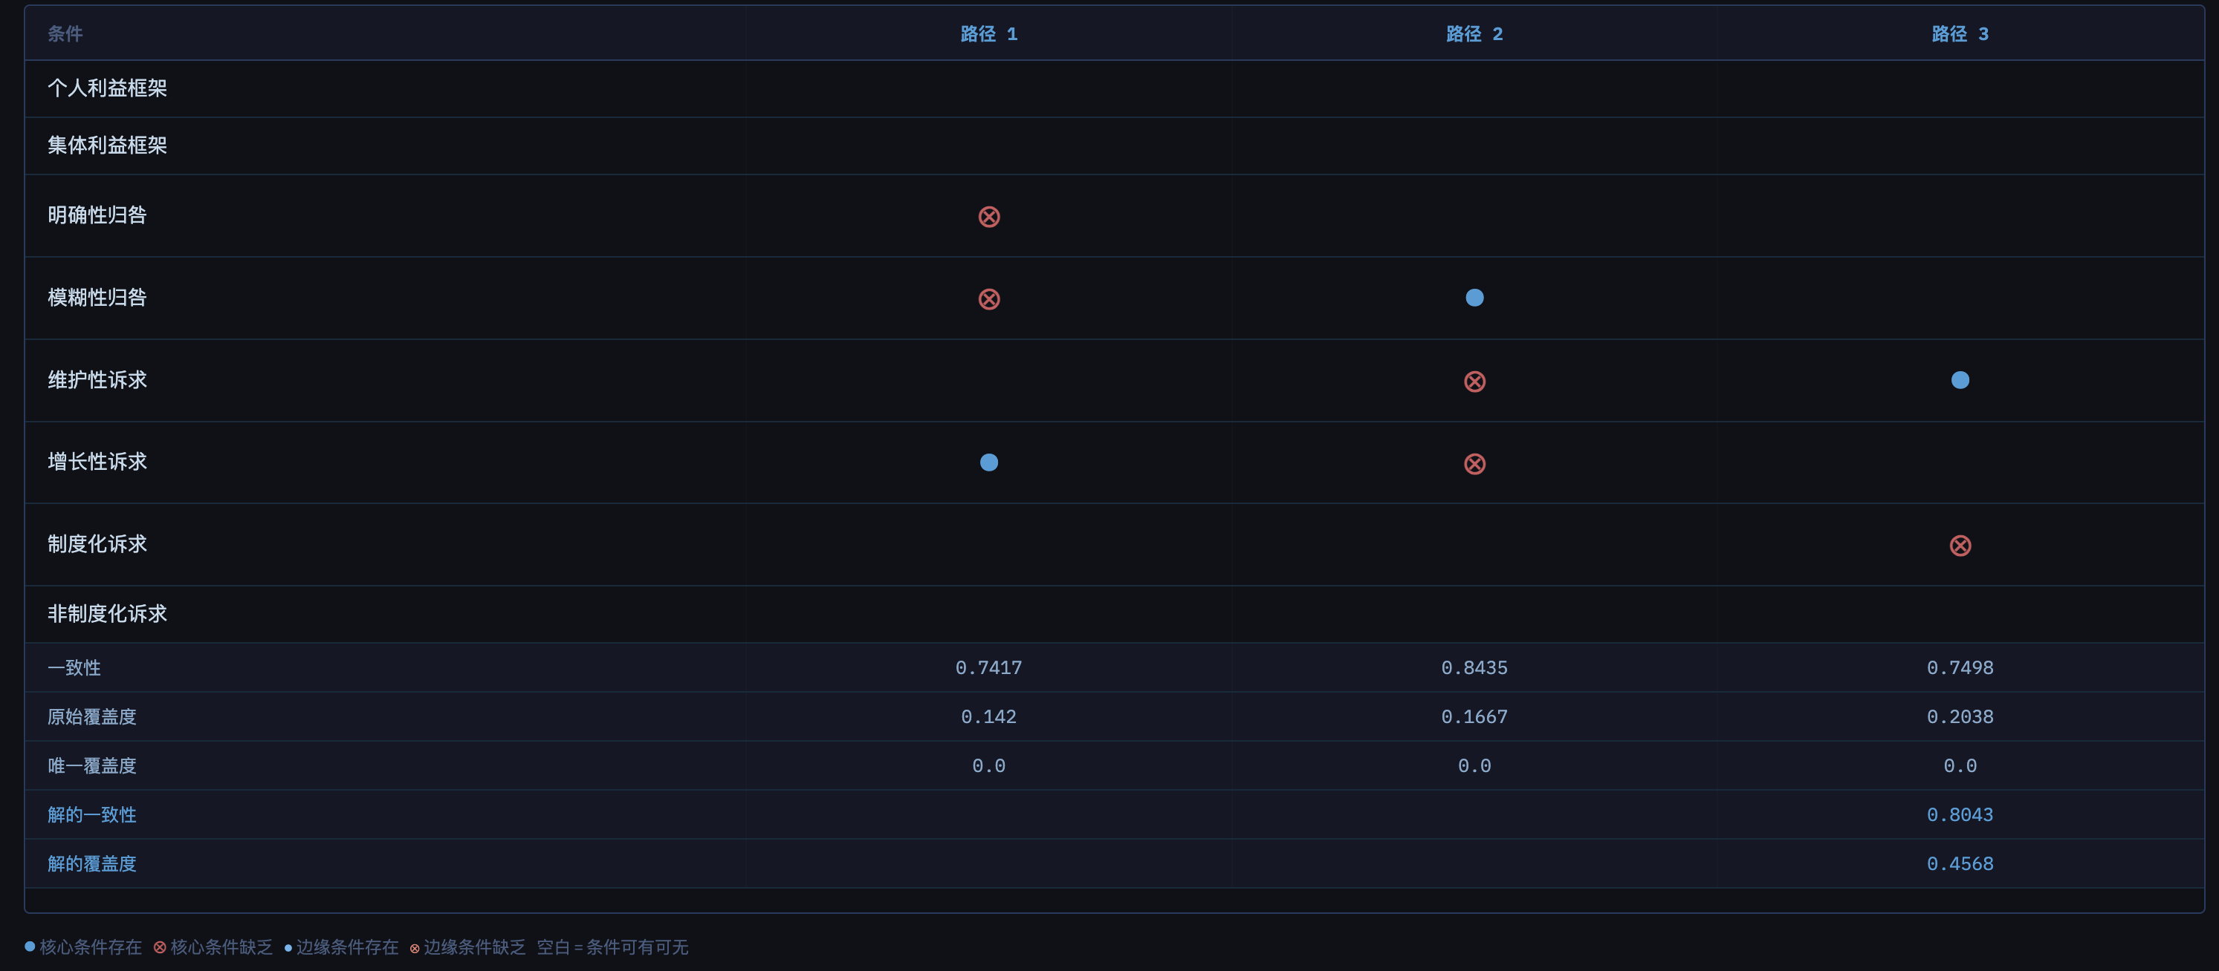
Figure 3. Configurational Analysis of Government Responsiveness
References
- Ragin, C. C., & Fiss, P. C. (2008). Net effects analysis versus configurational analysis: An empirical demonstration. In C. C. Ragin (Ed.), Redesigning social inquiry: Fuzzy sets and beyond (pp. 190–212). University of Chicago Press.
- Schneider, C. Q., & Wagemann, C. (2012). Set-theoretic methods for the social sciences: A guide to qualitative comparative analysis. Cambridge University Press.
- Dușa, A. (2019). QCA with R: A Comprehensive Resource. Springer.
- 杜运周, & 贾良定 (2017). 组态视角与定性比较分析（QCA）：管理学研究的一条新道路. 管理世界, (6), 155–167.
- Zhang, M., Chen, W., & Lan, H. (2019). What enables Chinese firms to fully acquire foreign high-tech firms? A fuzzy-set qualitative comparative analysis based on 94 cases. China Industrial Economics, (4), 117–135.

